Regulations:
A14

H.T No

Sreenidhi Institute of Science and Technology
(An Autonomous Institution)
Code No: 4B410 Date: 30-May-2019 (FN)

B.Tech II-Year II-Semester External Examination, May/June-2019 (Supplementary)
MACHINE DRAWING (ME)

Time: 3 Hours Max.Marks:70

Note: a) No additional answer sheets will be provided.
b) All sub-parts of a question must be answered at one place only, otherwise it will not be valued.
c) Missing data can be assumed suitably.

Part - A Max.Marks:2x15=30

Answer any two QUESTIONS.

1. | Draw the sectional front view and top view of double riveted, double strap chain butt joint to join plates of thickness 10 mm. | [15M]
2. | Draw sectional front view and left side view of Knuckle joint with sleeve for shaft diameter of 30mm. | [15M]
3. | Sketch the necessary views of a foot step bearing, for supporting a shaft of diameter 50mm. Give all important proportional dimensions. | [15M]

Part – B (Compulsory) Max.Marks:40

4. |  | Figure shows all the parts of an screw jack. Assemble all the parts and draw the following views: i. Sectional front view. ii.. Right side view  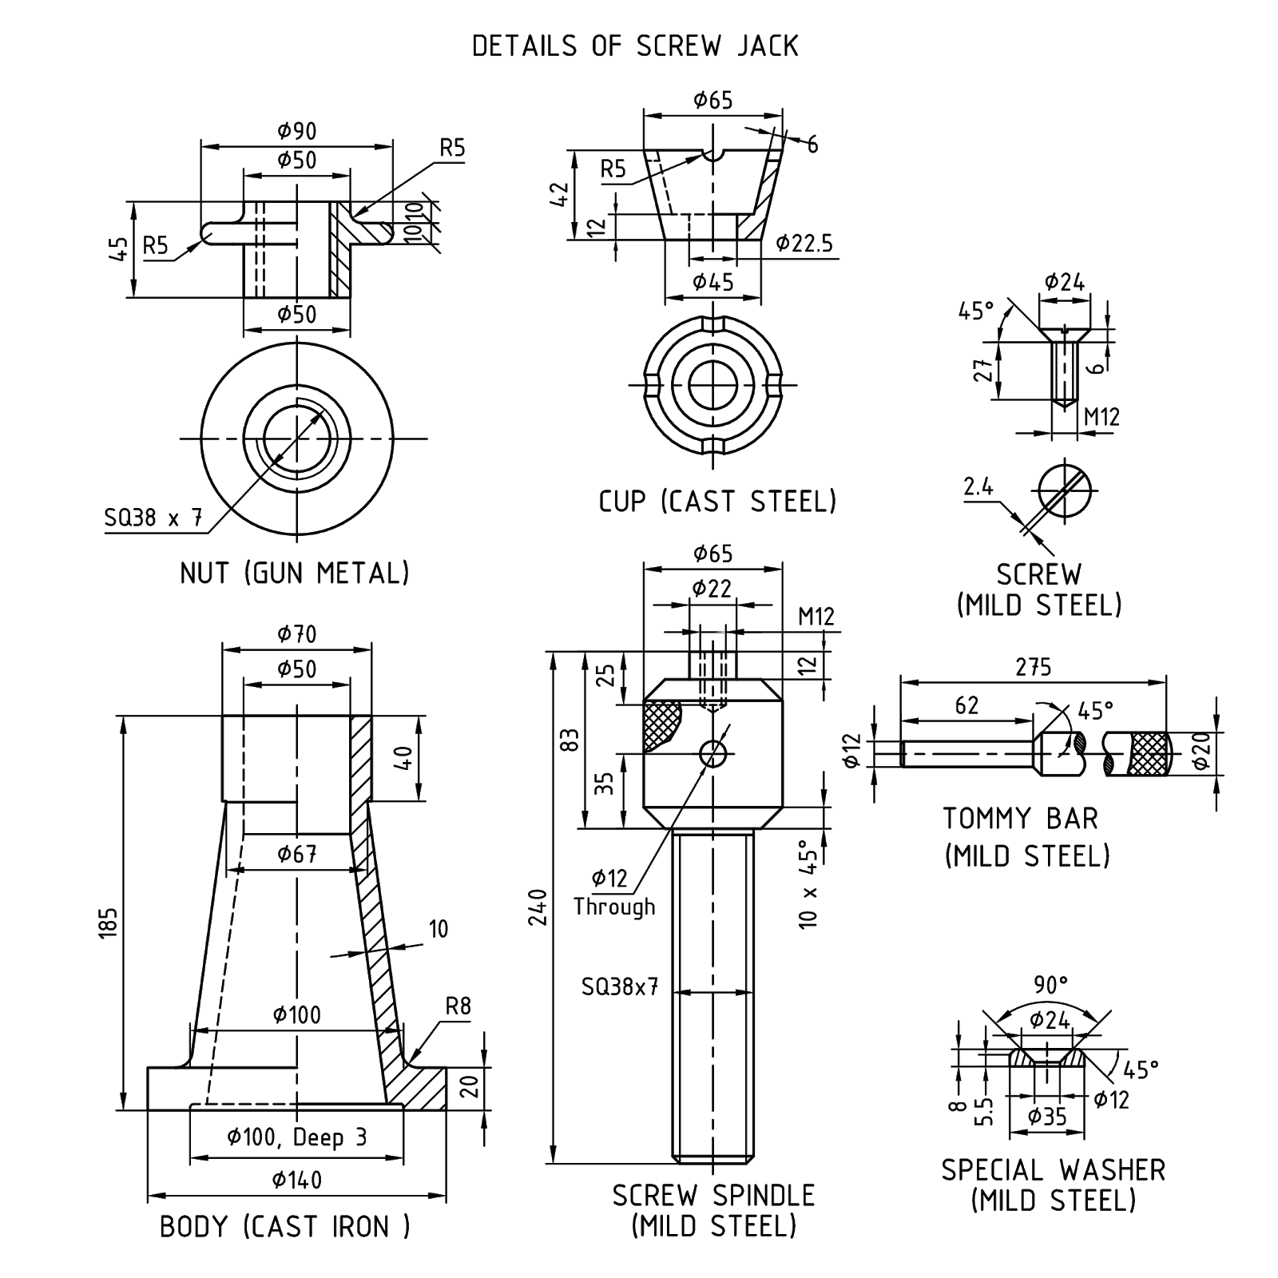
-- 00 -- 00 –

